Smith Commerce General Assembly
Sunday, October 23rd, 2022

Land Acknowledgement
Athmane Darenfeld

Agenda –

- Approval of the Agenda
- Approval of Minutes
- Statements by Members
  - Tara Rezvan – President
  - Amanda Morwick – Vice President Student Affairs
  - Ethan Kibel – Vice President of Operations
  - Emily Prpic – AB Chair

- Motions
- QCLA x SVF

- Discussion Items
- Aidan’s Finance Discussion

- Close of Assembly

Statements by Members

President – Tara Rezvan

HOCO BBQ Next Weekend
- If you want to volunteer let us know
- 10 people already volunteered

Partnership with ESU Initiative
- Targeting students in high school
- How can we get into high priority schools where we don’t see representation from
- In the past years we have seen classes diversify

Research Initiative
- New paid position out of the center for research
- Working on engaging undergraduate student in research

Diversity Day with CAC
- 100+ representatives
- CAC x commerce diversity executives

VP OPS – Ethan Kibel

Congrats to the CPRO on the election cycle

AB Chair – Emily Prpic

Hi Assembly! Hope everyone’s semester is going well!

First thing on AB’s end is Auditor hiring. The posting will be going live tonight and will be open for a week, so if you know anyone who might be interested (low commitment for a few weeks), direct them to ComSoc shop to apply. Recently we’ve been having lots of discussion around governance and discipline policy. I’d expect a discussion item by the end of the semester on this, but have been going through AMS processes, our old ComSoc policy and talking to stakeholders around what role ComSoc should/does/could play around enforcing policy and codes of conduct.

Motions

QCLA x SVF
Athmane Read the Motion below
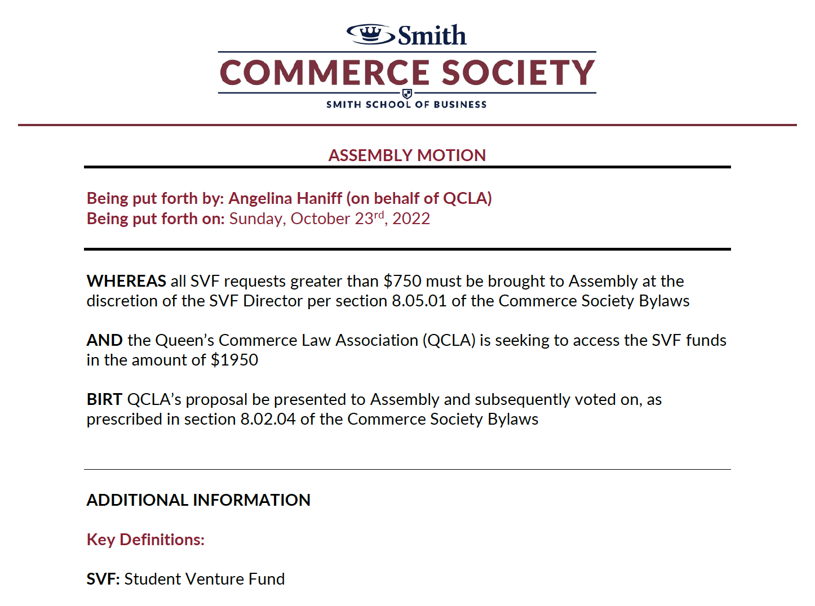

Elaboration – Julian, Brandon, and Brianna

QCLA NYC Trip
Mission: To provide Commerce students the opportunity to learn more about law by visiting prestigious law schools, firms, networking, and visiting educational law sights
Dels: 40 (<2% of the program)

UN Tour – 950 CAD
MoMA – 900 CAD

Questions directed at Presenters – 5 min

Tara: What is the cost per student

Answer: $500

Tara: Current ComSoc operating budget toward this already

Answer: We were told we could submit our budget later because we were waiting on confirmation from the Commerce Office. We are redistributing our budget to work this through

Sagaana: Who is eligible to attend this trip

Answer: 40 students

Brooke: Does that include exec?
Answer: Exec has to apply

Amanda: What is reserved for exec

Answer: Co chairs and events

Ethan: How did you budget this in previous years?

Answer: Comsoc

Sola: Why the MoMa over the Met

Answer: Because it is more expensive

Sam: Do you think it would be a barrier to dels applications to add the cost

Answer: Our delegate fee would not change regardless of if we are granted the funding

Joshua: Have you seen any corporate sponsorship

Answer: Its hard-to-get undergraduate sponsorships from law schools because we are far out of school

Tara: What is the educational value of the MoMA
Answer: Because it reflects indigenous communities in law. The exhibit is about land rights.

Mahir: Have you looked at visiting other indigenous exhibits other than the MoMA

Answer: Yes, but this is the top level experience

* Angelina, Julian, Brandon, and Brianna are placed in a breakout room *

Discussion period – 10 min

Tara: POI – Angelina has to leave

Mahir: Are there other conferences that were denied funding

Tara: Previously, SVF decided that they were not sponsorship funding and didn’t want to pick up the slack when sponsorship couldn’t cover. The most similar instance was a team bonding social

Amanda: They are an internal club unable to be covered by the budget. Not a club that relies on sponsorship because they are not a conference but an internal club

Tara: In support, as if they aren’t granted their funding then the initiatives just wont happen

Aidan: On behalf of the CFOs, there hasn’t been an event of any sort that was approved by CFOs so it is reasonable that they would look for other means to look for funding

Annabelle: This is what the SVF is for and it Is not just benefiting their club but open to all students on application

Emily: There is a lot of money in the fund

Nameera: Number of dels does not equal 2% of the students

Laura: 40 is limited by the number of seats on the bus

Question period re-opened

Nameera: Can more students attend the trip

Answer: Yes, new conditionality condition created on the assumption that they bring 44 people

Friendly Amendment

SVF funds in the amount of $2150

Ask: 950/40 + 900/40
Per person: 23.75 (rounded to 24) + 22.5 = 46.25
For 44 dels: 2046
Added buffer (~$100): $2150

Mahir: If they do not have 44 people attend do they get the same amount of money?

Tara: No they don’t get any money

Voting

Motion Passed

Discussion Items

Financial Resource Expansion Project

Current Review

- $55 student fee, projected revenue of $121,440
- $15 SVF fee
- Requested funding in 2022 of $289,536.49 (greater than the previous 4 years)
- Reduced funding grants to $198,000
- $100,000 per semester in budgeting after student revenues collected
- ComSoc student fee was set in 2015, could be at $68
- EngSoc student fee is $82.33, bringing in ~$288,000
- ASUS brings in ~$400,000

Options

- Increasing Student Fee
- Sourcing ComSoc wide corporate sponsorship
- Individual club opt-out fees similar to AMS

Cost Reduction Methods

- Heavily standardize exec budgets
- Withdraw significant funding
- Application for funding on case-by-case basis

Questions directed at CFOs – 5 min

Brooke: How would we compensate corporate sponsorship

Answer: Corporate names on the awards given out at the ComSoc appreciation dinner

Joshua: Could the opt-in have you not be able to join a club

Answer: Those opt outs are only for the SVF and are not applicable to ComSoc operating budget

Brooklyn: ComSoc sponsorships under the agreement that we would promote their company on multiple clubs. In terms of increasing fees how would you determine it?

Answer: We have had discussions on that and feel it could be closer to what eng students are paying. It will be something students are comfortable with

Brooklyn: Is there a way to have those who are able to opt in opt in on a per case basis

Laura: What is the process in changing these fees

Answer: Reaching out to the registrars office if the society passes

Emily: It might be in policy that if the student fee changes there is a student body vote. In terms of conditional funding, should there be greater quality/attendance/engagement thresholds

Answer: There does need to be an overhaul on spending requests. We gave a handout on what is and is not allowed

Ethan: Sponsorship is a given. In terms of assigning a fee, looking at the behavioural differences between 2017 and 2022. Can we look at what EngSoc requests? Because we don’t know how they delegate their budgets?

Aidan: Point on EngSoc, they only have 10 executives

Tara: I would be interested to see what the tuition increase has been since 2015. Suggestion for the CFO team, look at the common themes for requests that you wish you could grant for a new optional fund for those specific events

Motion to extend for 5 minutes

Aidan: Something that comes to mind is transportation. We had to reject all transportation

Sam: An idea is giving a budget to clubs to help them work with

Joshua: The 2022 requested budget would you expect that to be the same next year (semester)

Aidan: I think it was a carry over effect (so no?)

Emily: Is it possible to see at the end of the term to see the amount people actually spent vs how much they budgeted. Are people overestimating how much things cost?

Aidan: We talked to Smith finance about this because corporate sponsorship is down in general. Because things can be done virtually, companies are a lot less likely to sponsor events that could be done virtually

Brianna: A set budget would be really helpful, with planning conferences its hard to know how to budget with things that have changed so much in the past years. Building budgets per executive portfolio with industry standards

Aidan: We want to avoid putting a cap on budgets because of the unique nature of each club

Abbie: In terms of the society makeup how did that change between 2019 and 2022?

Answer: Like one or two. Less so the number of clubs but the rep

Assembly called to a close

